Audio Recognizer

Thirteenth group：何鹏程 朱云龙 梁骏杰 陈柏山

**Contents**

1. Introduction 3

1.1 Writing purpose

1.2 Background

2. Description of project

2.1 Project objectives

2.2 Demand analysis

2.3 Task decomposition

2.4 System structure drawing

2.5 Detailed module design

3. Job instructions (SOW)

3.1 scope of project

3.2 organizational structure

3.3 Personnel allocation

3.4 Project schedule

3.5 Collaboration and communication

3.5.1 Internal collaboration

3.5.2 Project communication skills

4. Learning algorithm

5. Project required interfaces

6. Test

7. Milestones

8. The risk plan

# Introduction

## 1.1 Writing purpose

In order to ensure that the project team completes the project objectives on time with good quality, easy to project team members to better understand the project situation, a reasonable and orderly to project work to each process, it is necessary to file the form, put in the project life cycle within the scope of work, each work task decomposition, the project team structure, team members have to work responsibility, team communication inside and outside collaboration mode, progress, project content such as internal and external communication collaboration mode, progress and describe in writing a way out.So that each person in the project development process can play their strengths and role, so that the whole project development process can be smooth and orderly, and provide effective and powerful progress reference for the project development.

## 1.2 Background

With the rapid keyword retrieval technology based on massive audio content becoming more and more mature, it plays an important role in people's spirit, life and other aspects.When we overhear a song or a piece of music, but we need to know the name of the song in order to record, but there is no way to start.In order to increase the user experience, this product is a simple and easy to use music recognition application, the user can use this function to identify the current environment is playing the song information, give people in the break time to bring new surprises and experience.This is also a way to find good music, after all, a good song, worth recommending to more listeners.With it, you can explore more new music tracks with your friends and share them around the world.

# 2. Description of project

## 2.1 Project objectives

Player can quickly and accurately identify the current environment to play the song information.

# 2.2 Demand analysis

1. Do a good job of the current research on music player. Through the research on the current function of listening to and recognizing songs of music player, we can help the project more clearly conceive the general structure and appearance of the system developed by ourselves.

2.Search for technical knowledge and prepare tools and environment for the project.

3.describe system functions and make test plans.

4.Determine the interface style, coding language.

## 2.3 Task decomposition

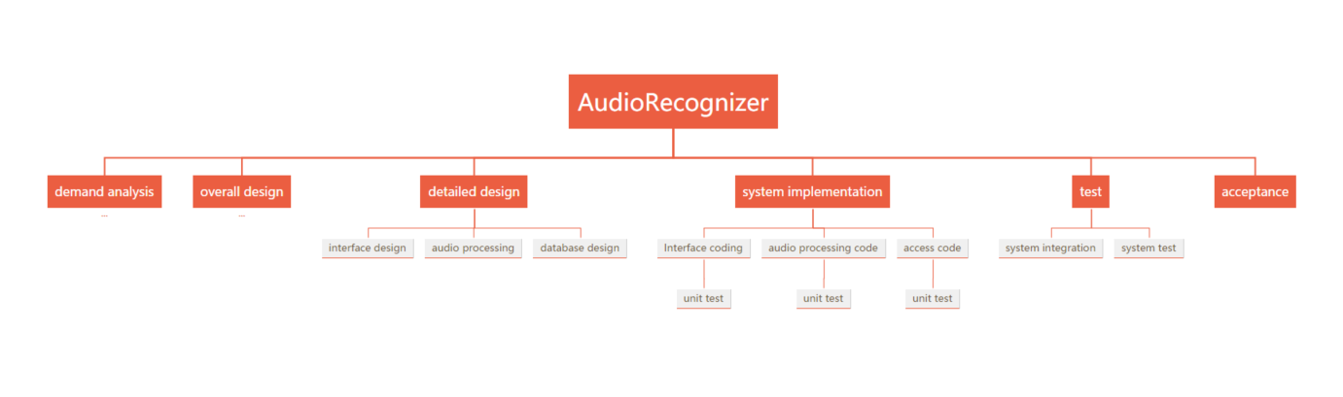

Diagram 3-2 Work breakdown structure diagram

## 2.4 System structure drawing

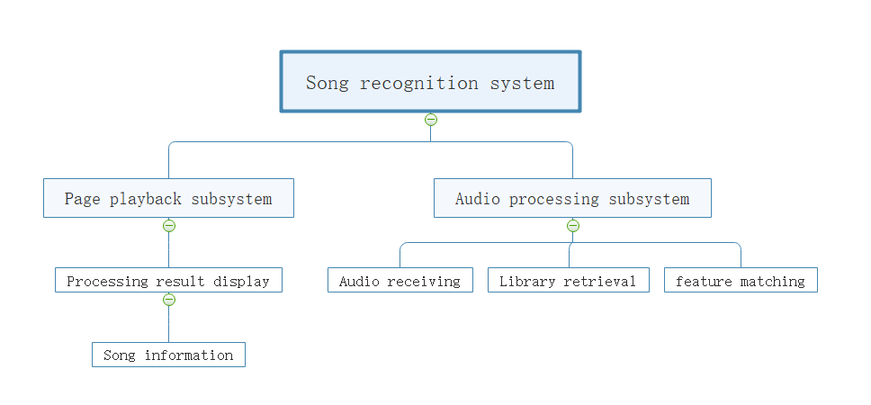

Digram 3-3 system structure drawing

## 2.5 Detailed module design

1. Page module design: this page is divided into three parts: the song recognition button, the information display part of the retrieved song returned in the background, and the control button of the returned song playing.

2. Audio processing module: Fourier algorithm is used to convert audio time-domain information into frequency domain information, and audio fingerprint idea introduced by shazam is used to extract audio characteristic values;

3. Database module: the database processing module is divided into database storage design and access operation. The database adopts hash index storage method. The retrieval USES a series of methods such as matching fingerprint to find the music with the highest matching degree in the database and then returns the information such as ID.

# 3. Job instructions (SOW)

## 3.1 scope of project

(1) project development module

|  |  |
| --- | --- |
| **order** | **module** |
| 1 | interface presentation |
| 2 | receiving voice |
| 3 | audio processing |
| 4 | data store |
| 5 | library retrieval |
| 6 | music play |

(2) Major deliverables

|  |
| --- |
| **work products** |
| Requirements specification |
| Detailed design specification |
| Interface specification document |
| operation manual |
| Project change requirements documentation |
| Test documentation |

## 3.2 organizational structure

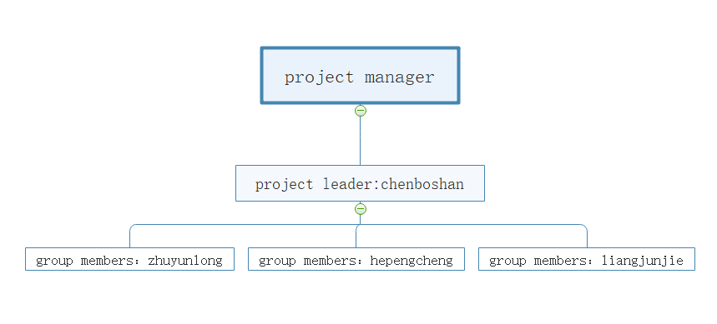

Table 3-1 [organization](javascript:;) [chart](javascript:;)

## 3.3 Personnel allocation

|  |  |  |  |  |  |
| --- | --- | --- | --- | --- | --- |
| Order | [job](javascript:;) [title](javascript:;) | specific personnel | Start time | End time | Average daily workload（Working hours） |
| 1 | Demand analysis | The whole team | 2019.2.26 | 2019.3.5 | 3 |
| 2 | Overall design | The whole team | 2019.3.6 | 2019.3.12 | 4 |
| 3 | Detailed interface design | 朱云龙，何鹏程 | 2019.3.13 | 2019.3.24 | 2 |
| 4 | Detailed database design | 陈柏山 | 2019.3.13 | 2019.3.24 | 2 |
| 5 | Audio processing design | 梁骏杰 | 2019.3.13 | 2019.3.24 | 4 |
| 6 | Interface code | 朱云龙，何鹏程 | 2019.3.25 | 2019.4.30 | 4 |
| 7 | Database design  coding | 陈柏山 | 2019.3.25 | 2019.4.30 | 2 |
| 8 | Audio processing coding | 梁骏杰 | 2019.3.25 | 2019.4.26 | 2 |
| 9 | Interface unit  testing | 朱云龙，何鹏程 | 2019.4.28 | 2019.4.30 | 3 |
| 10 | Database unit  test | 陈柏山 | 2019.4.28 | 2019.4.30 | 2 |
| 11 | Audio processing unit test | 梁骏杰 | 2019.4.28 | 2019.4.30 | 4 |
| 12 | Integration testing | The whole team | 2019.5.1 | 2019.5.4 | 2 |
| system test | The whole team | 2019.5.4 | 2019.5.8 | 2 |

Table 3-2 Personnel allocation

## 3.4 Project schedule

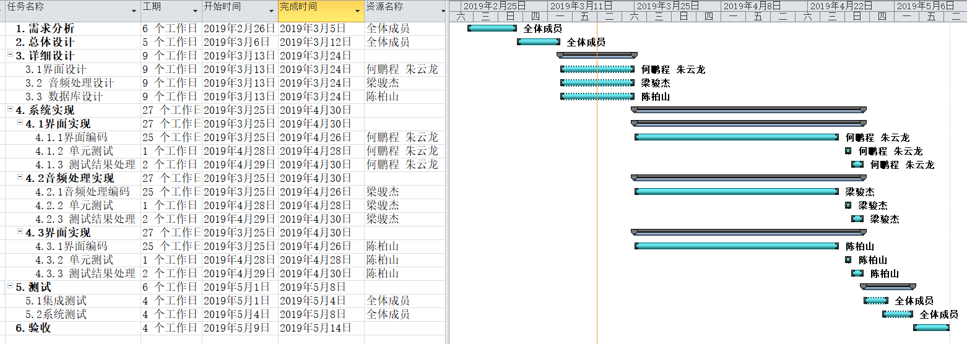

Diagram 3-1 project schedule

## 3.5 Collaboration and communication

Project communication management includes the processes required to ensure timely and reasonable generation, collection, distribution, storage, extraction and final utilization of project information. The objective is to ensure that all project stakeholders (including the project team, stakeholders, customers, and sponsors) receive and respond to timely information. Project communication runs through almost every link of the project. Effective communication management contributes to the success of the project. All stakeholders should understand the impact of communication on the project.

### 3.5.1 Internal collaboration

In order to ensure the smooth progress of the project development process and effective communication of information, the following communication plan is required:

1. Members of the project team shall have oral communication from 18:00 to 19:00 every day;

2. Submit weekly report before 14:00 every Friday, and make format template;

3. Held weekly project meetings from 16:00 to 17:00 every Friday, and issued meeting minutes to relevant project personnel after the meeting, which explained the progress and existing problems of the project;

Timely submit the problem report, the problem can be submitted through the network, the project leader will timely access to problem information.

### 3.5.2 Project communication skills

1. Use correct expressions. Communication must be purposeful. Before exchanging information, senders should consider their intentions and be concise. Express yourself in plain words.

2.Improve your listening skills. Communication is not just talking, but talking and listening. Listening is not only an important way for us to get first-hand information about others and get to know them correctly, but also the best way for us to show respect to others.

3.Avoid endless arguments. The result of this endless debate is inconclusiveness, which not only leaves the problem unresolved, but also delays its resolution.

4.Keep communication channels open. Communication is of course important, but without smooth communication channels, the organization will inevitably show spontaneous unorganized state, and it will be impossible to obtain the real information needed, and the operation efficiency of the entire organization will decline.

5.Use effective communication tools. Within the project organization, the relevant mature project management software, E-mail system, office automation system and other tools are usually used to support the generation, transmission and storage of various information of the project. The use of these tools greatly improves the efficiency of communication, pulls in the distance between the two sides, and reduces unnecessary interviews and meetings.

6. Grasp the principle of communication. One is the difference between internal and external communication. That is to ask the team as a whole to external consensus, a team to use a voice; Second, informal communication contributes to harmonious relations. Third, the other party can accept the communication style; Fourth, the principle of communication upgrade, namely the first step, and the other side of communication; The second step is to communicate with the superior of the other party. Step 3: communicate with your superiors. Step four: communicate with your superior and your counterpart's superior. Fifth, remove communication barriers.

## Learning algorithm

The algorithm to learn: the Fourier algorithm

Idea used: audio fingerprint feature matching

This project needs to learn the Fourier algorithm (FFT) to convert audio time-domain information into frequency domain information, and the audio fingerprint idea introduced by Shazam. This is a knowledge field that we have never been exposed to and understood before, so our team members decided to spend a week to learn and master FFT and audio fingerprint before the project started coding.

## Project required interfaces

1. Recording interface: click the front-end song recognition button to trigger the recording event, and call this interface to limit the sampling size, frequency channel number and other parameters of recording and record;

2. I/O interface: call this interface to receive and read the audio stream;

3. Fourier transform interface: after clicking the song recognition button, the background calls this interface to transform the Fourier transform of the transmitted audio and extract the frequency domain information;

4. Fingerprint extraction interface: after receiving the frequency domain information, this interface is called to extract the audio fingerprint characteristic values;

5. Database operation interface: call this interface to access audio information;

6. Player interface: when the front-end song play button is clicked, the play music event is triggered, and this interface is called to play the returned music.

## [Test](javascript:;)

|  |  |  |  |  |
| --- | --- | --- | --- | --- |
| [type](javascript:;) [of](javascript:;) [test](javascript:;) | [test](javascript:;) [content](javascript:;) | submission | Test time | head |
| Unit testing | Whether the front-end page UI effect can be achieved, and whether the recording, playing and information display functions can achieve the desired effect | Test results, bugs, solutions | 2019.4.28 | 朱云龙、何鹏程 |
| Whether the audio processing module decomposes the audio into frequency domain signals as expected and extracts fingerprint information with high recognition degree | 2019.4.28 | 梁骏杰 |
| Whether the database design module can establish an efficient hash access method and realize the storage and fast reading of fingerprint information | 2019.4.28 | 陈柏山 |
| Integration testing | Whether the audio recorded in the front end can be correctly transmitted to the background for processing, and whether the processed fingerprint information can be retrieved in the database and accurately matched and returned to the front end for playing | 2019.5.4 | [all](javascript:;) [members](javascript:;) |
| The system test | Package the system and imitate the user's operation process to see if the desired effects can be achieved correctly | 2019.5. 8 | [all](javascript:;) [members](javascript:;) |

Table 6-1

## Milestones

The system adopts modular development. There are 8 milestones in the development process:

Table 7-1

|  |  |  |  |
| --- | --- | --- | --- |
| Milestone name | Date of completion | Deliverables |  |
| M1 Demand analysis milestone | 2019.3.5 | Demand specification | [all](javascript:;) [members](javascript:;) |
| M2 Detailed design milestone | 2019.3.19 | Detailed design specification | [all](javascript:;) [members](javascript:;) |
| Coding milestone | 2019.4.26 | Code status, code walk record | Responsible person of each module |
| Interface test milestone | 2019.4.30 | Test results, bugs, solutions | 朱云龙、何鹏程 |
| Audio processing test milestone | 2019.4.30 | 梁骏杰 |
| Database test milestone | 2019.4.30 | 陈柏山 |
| Integration test milestone | 2019.5.04 | [all](javascript:;) [members](javascript:;) |
| System test milestone | 2019.5.08 | [all](javascript:;) [members](javascript:;) |
| End of project milestone | 2019.5.14 | Requirements specification;  Detailed design specification;  Interface specification document;  operation manual;  Project change requirements documentation;  Test documentation | [all](javascript:;) [members](javascript:;) |

## The risk plan

Risk refers to the events that may occur during the course of the project, which will have a significant impact on the completion of the project according to the expected time, resources and budget. The goal of risk analysis is to identify these events, try to avoid them and formulate measures to deal with them once they occur.

The following risk list is a risk identification, risk assessment, risk response, and finally the project risk plan

|  |  |  |  |  |  |
| --- | --- | --- | --- | --- | --- |
| Project risk management | | | | | |
| Judgment criteria of risk occurrence probability: | | | | | |
| High risk: >60% chance of risk: 30-60% chance of risk low risk: <30% chance of defense | | | | | |
| Order | risk description | probability of occurrence | incidence | risk grade | Risk response plan |
| 1 | Due to time constraints, it could not be finished on time | [low](javascript:;) | maximum | high | Full consideration of various potential factors, appropriate margin; Detailed task breakdown for easy assessment; In case of necessary delay, the group leader shall communicate with the relevant person in charge in time and apply for extension time. |
| 2 | The system does not have enough test time | high | Big | high | Continuous monitoring, project progress control with the progress of the project, to ensure that there is enough time for each link. |
| 3 | There are some problems in developing software structure system, which make the completed software products fail to achieve the predetermined goal of the project | High | High | [middle](javascript:;) | Choose legal software development |
| 4 | Developers have no project development experience and lack of technical expertise | High | High | High | Carry on the related knowledge study, consult the related technical domain expert, solve the problem in the actual combat. |
| 5 | In the process of software project development and implementation, the necessary  management tools, development tools and testing tools are not in place in time | Low | Big | High | Identify the source of the tools or possible alternatives at the start of the project, and track and implement the tools in place before they are needed. |
| 6 | Team members are unable to participate in the design due to accidents | Middle | Middle | High | Make a personnel replenishment plan in advance, and invite foreign aid at critical moments. Or do a character breakdown plan for unexpected people. |

Table 8-1